Kuitpo Day Walk Information Package

Date: Monday 19th or Tuesday 20th July 2021
Time: 8.45am - 4.00pm
Meet: Forestry SA Kuitpo, 495 Brookman Rd, Kuitpo
Some Parking available along Harvey Road.
Finish: At meeting point above
Route: Orienteering conducted in course by Forestry
Walk is a loop from Forestry HQ – south along Heysen to Prospect Hill trail head - (if time permits then a return walk from Prospect hill trail head to Kyeema) – Christmas Hills Forest (via forest between Heysen Trail and Brookman Road) – Forestry HQ
Group 1 – orienteer and then walk (Name)
Group 2 – walk and then orienteer (Name)

What to Bring
- Daypack
- Lunch and snacks for up to 8 hours
- 2L of water
- Raincoat
- Rain pants (weather dependant)
- Sun hat and warm hat
- Warm clothes such as a fleece jumper to wear when not active
- Sunscreen
- sunglasses
- Pen and paper
- Whistle
- Personal medication such as asthma puffer etc…
- Personal first aid kit
- Phone with phone numbers entered
- Smile
- Camera (optional)
- Toileting kit
What to Wear
- Comfortable walking shoes
- Thick walking socks
- Comfortable walking clothes that can be added to (must also be sun smart)

Leaders will bring
- Maps and compasses
- First aid kit
- Phone
- Your medical details
- Emergency shelter
Important Contacts (enter into your phone)
[Name] 0000 000 000
[Name] 0000 000 000
[Name] 0000 000 000

Kuitpo Forest Office (08) 8391 8800
Brookman Rd, Meadows SA 5201
Mount Compass Medical Centre (08) 8556 8365
5/30 Victor Harbor Rd, Mount Compass SA 5210
Flinders Medical Centre (08) 8204 5511
Flinders Dr, Bedford Park SA 5042
Emergency Services 112 (from a mobile)
000

Assessment
As a part of this experience you are required to write a 1 page reflection to include in your Outdoor Education Portfolio. You may choose to collate photos and videos to support this. See assessment item 3 for details

Additional
- You may wish to access the BLSA website prior to this experience and begin a bushwalking logbook.

Brief Plan
 | Group 1 (Dave) | Group 2 (Wally)
8.45 | Meet leader in front of forestry HQ  Clarify COVID rules  Establish outcomes for day  Equipment check | Meet leader behind shelter in front of Forestry HQ  Clarify COVID rules  Establish outcomes for day  Equipment check
9.00 | Begin instruction for orienteering including emergency procedures, timing, how to work with a partner etc… | Begin walk loop with procedures established  Timings managed within the group
10.00 | Finish orienteering  Begin walk loop with procedures established  Timings managed within the group | Continue walking
12.00 | Suggested lunch stop  Group to determine whether to visit Kyeema and by what time they will need to loop back to return to Forestry HQ in time | Suggested lunch stop  Group to determine whether to visit Kyeema and by what time they will need to loop back to return to Forestry HQ in time
2.00 | Continue walking | Return time to aim for  Begin instruction for orienteering including emergency procedures, timing, how to work with a partner etc…
3.00 | Meet with leader in front of forestry HQ for debrief and closure | Meet with leader behind shelter in front of Forestry HQ  for debrief and closure

Important.
- All directions provided refer to the general direction of travel rather than the specific direction of travel at the time of leaving track junctions.
- Always stay together in your group.

Route Travelled | Emergency Escape Route
Begin at Forestry HQ travelling south along Heysen trail to Prospect Hill MTB trail head. | West to Brookman Road
If time Permits continue south on Heysen trail to Kyeema Conservation Park | South to Kyeema car park
Return north along Heysen trail to Prospect Hill MTB trail head. | North to Brookman Connor Road
Return south along Christmas hill road to Tinjella trail | West to Brookman Road
East along Tinjella trail through Christmas hill forest to join Heysen Trail | West to Brookman Road
South on Heysen trail to Forestry HQ | West to Brookman Road

Maps
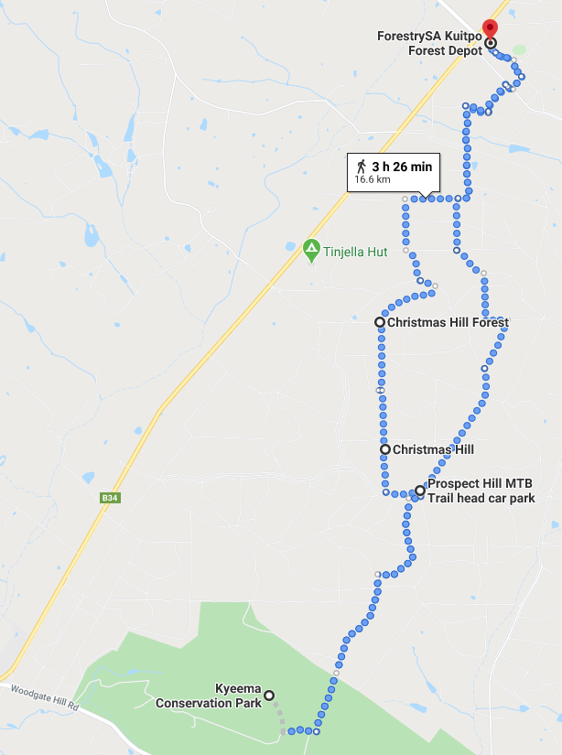
Brookman Road
Christmas Hill Road
Heysen Trail
Start

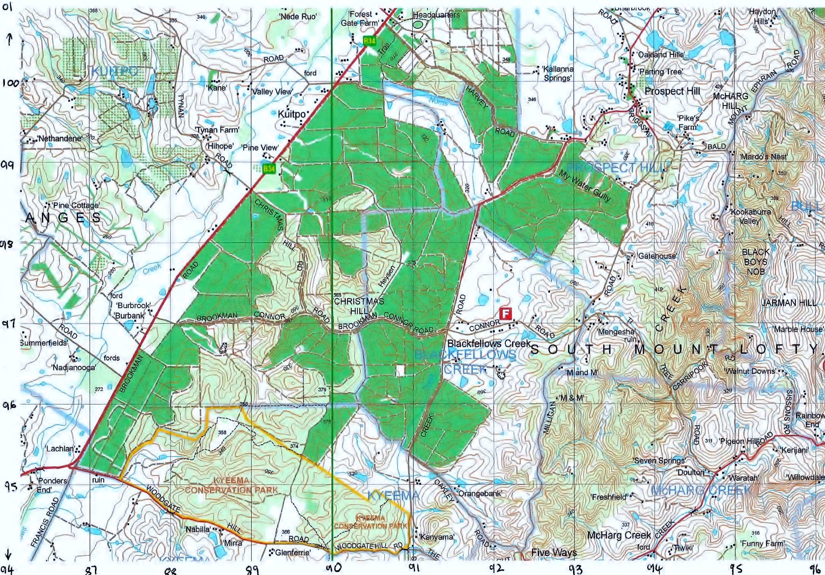
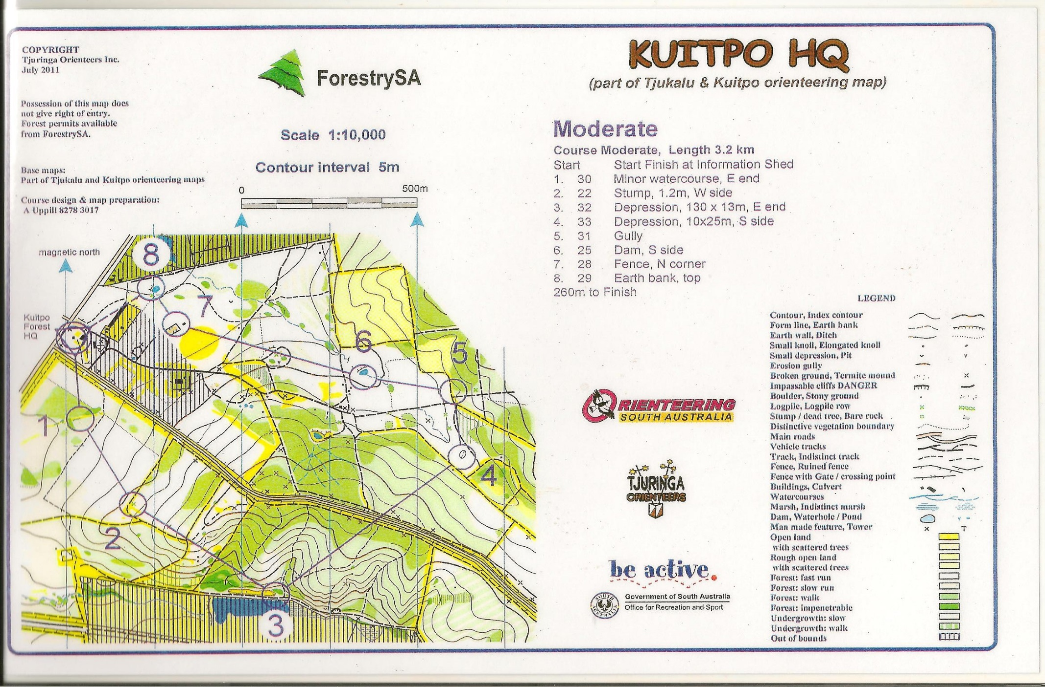

Risk Assessment and Management

Day Walk – Adelaide Hills
Kuitpo Forest
Flinders Uni and Sturt Gorge
Table of Contents
Risk Assessment and Management 7
Context Establishment 8
Risk Identification 9
Risk Analysis and Management Strategy 10
Dynamic Risk Assessment Framework 21
Emergency Management Planning Details 22
Planning 22
Preparation 22
Response 22
Recovery 23
Incident and Emergency Response Plans 23
Accident Report Form 24
Emergency – Serious Incident Form 25
COVID-19 Procedures for Outdoor Activities 27

Context Establishment
Activity
Type | Single day bushwalk and orienteering
Purpose of activity | Build an understanding of walking longer distances and requirements associated such as  - Plan and prep  - Equipment including clothing, food, water, etc…  - Technical capabilities including navigation and timing  - Essential capabilities such as leadership styles and debriefing
Date and time | 8.45am – 4pm  July 2021
Participant
Participants (number and group) | 30 participants plus 2 Instructors as 2 separate groups (1:22 for day walks with adults - AAAS)
Experience | Mixed experience – students studying sport or PE so generally a level of fitness identified
Restrictions | See medical summary sheet collated from FlinSafe
Health and wellbeing | See medical summary sheet collated from FlinSafe
Gender considerations | None known – all above age of 18
Cultural considerations | None known
Environment
Location (s) | Kuitpo Forest  Flinders Uni and Sturt Gorge
Climate and weather | Conditions will be varied during these days and therefore weather information will be included in information packages and participants are required to also gather this information as part of their leadership preparation. Generally these areas experience mild to cold conditions and some rain is likely during this time of year. Instructors must make sound judgements relating to weather and hail or lightning must force a cancellation of activity. As this area is governed by forestry fire warnings and logging closures will also be considered and may result in location change or cancellation.
Sustainability | - Apply leave no trace principles in all locations  - National parks guidelines for conservation parks applied even though officially forestry are (Kyeema is recognised conservation park)  - Apply considerations for Phytophthora – cleaning principles on shoes and equipment that contacts soil.  - Use identified paths only
Land owner / manager requirements | - Not to proceed on catastrophic fire danger – check parks advice on extreme fire danger.  - No permits as this is part of an educational experience rather than as a tour operator.
Leadership | - Abide by ratio recommendations (AAAS) of 1:22  - Minimum day walk leader required as tracks are class 1-2
Roles and responsibilities | - Leaders of each group to enact duty of care and align with roles outlined in leader prep package.  - Leaders are to make sound and informed judgement within their qualification or equivalent recognition of experience.  - Students and Leaders to complete FlinSafe agreement and abide by this.
Competencies required | - Day walk leader or equivalent
Supervision | - Abide by ratio recommendations (AAAS) of 1:22  - While orienteering outer boundaries are set, must always work in pairs with a phone  - If lost, head west to Brookman Road
Logistics and equipment
Equipment | Outlined in information pack
Logistics | Outlined in information pack
Communications | Outlined in information pack  - Phones (leaders and students)

Has anything been identified from a previous relevant experience?
- none
What action has been taken?
- For 2020 corona virus procedures have been included and carried in 2021
- Completion of AAAS guidelines have reshaped the risk planning documentation

Risk Identification
Risks (list of possible events where an accident, injury or loss could occur)
- Motor vehicle accident | - Exposure to elements including development of hypothermia or hyperthermia | - Heat stress / dehydration
- Inadequate nutrition or hydration | - infection, gastro, etc… | - Medical emergency
- Physical Injuries | - Manual handling | - Bites and stings
- Sun burn | - Natural disaster | - Split group or lost participant
- Anxiety | - Exposure to a virus

Now transfer to below and identify for each risk, the risk factors under categories of:
- (P) People (leaders and participants)
- (En) Environment
- (EL) Equipment and Logistics
Then complete
- Assessment of risk
- Identification of management strategies
- Implementation of risk management

Risk Analysis and Management Strategy
Risk Calculation Matrix
 |  | Consequence
 |  | Insignificant (I) | Minor (mi) | Moderate (Mo) | Major (MA) | Catastrophic (C)
Probability | Almost Certain (A) | High (H) | High (H) | Extreme (E) | Extreme (E) | Extreme (E)
 | Likely (L) | Medium (M) | High (H) | High (H) | Extreme (E) | Extreme (E)
 | Possible (P) | Low (L) | Medium (M) | High (H) | High (H) | Extreme (E)
 | Unlikely (U) | Low (L) | Low (L) | Medium (M) | High (H) | High (H)
 | Rare (R) | Low (L) | Low (L) | Medium (M) | Medium (M) | High (H)

Risk Calculation Matrix Descriptors
Probability of Risk Factors (P) |  | Consequence of Risk Factors (C)
Almost Certain (A) | Expected to occur in most circumstances; and/or high level of recorded instances | Insignificant (I) | no injury or fatality; first aid not required
Likely (L) | Will probably occur in most circumstances; and/or regular recorded instances | Minor (mi) | injury requiring first aid and able to continue
Possible (P) | might occur at some time; and/or few, infrequent, random recorded incidents | Moderate (Mo) | injury requiring medical treatment, possibly some hospitalisation and/or unable to continue
Unlikely (U) | not expected to occur; and/or no recorded incidents | Major (MA) | extensive injuries requiring significant hospitalisation
Rare (R) | may only occur in exceptional circumstances | Catastrophic (C) | fatality, possible threat to life or severe injuries causing permanent disablement

*NOTE: specific location information to be highlighted
Kuitpo Forest
Flinders Uni and Sturt Gorge – for this trip students will create the risk plan at the beginning of the trip

Obtain From Risk Factor Identification |  | Risk Analysis |  |  | Risk Management
Risk | RF | P | C | Risk Level | Comments on Risk | Management Strategy | Resources Required | Residual Risk | Communication Required
1 - Motor vehicle accident (P) | 1 - fatigue | U | C | H | Driving is not within the timeframe of the field trip as participants will meet at and leave from the identified location, however they will be informed of the risks associated, and be provided with location information. | - Appropriate licences  - Locations within 1.5 hour of Adelaide  - Finish time is prior to dark | - Participant information package including maps | R MA  M | Leaders to discuss vehicle logistics prior to departure
 | 1 – reckless driving | U | C | H |  | - Appropriate licences  - Provide location information prior  - Must obey road rules |  | R MA  M
1 - Motor vehicle accident (En) | 1 – hazards on the road | U | MA | H |  | - Appropriate licences  - Must obey road rules |  | R MA  M
1 - Motor vehicle accident (EL) | 1 – unclear route | R | I | L |  | - Appropriate licences  - Clarify routes between leaders before departure  - Info packs |  | R I  L
2 - Exposure to elements including development of hypothermia or hyperthermia (P) | 2 – incorrect information to participants including weather details | P | Mo | H | Students undertake preparation workshops and are required to access weather information themselves. Weather info is also provided in information packages. A packing list will assist with preparation – leaders should check that appropriate clothing is worn and equipment has been packed prior to commencing | - Participant info books  - Participants required to access weather  - Equipment checked prior to departure | - First aid kits including emergency blankets  - Equipment lists to leaders and participants | R Mi  L | Info in prep workshop
 | 2 – inappropriate supervision | U | Mo | M |  | - Maintain ratios  - Constant supervision of group while walking  - Lost procedures identified for orienteering  - Appropriate management strategies such as markers  - If lost stay by the track or head west to brookman road and send a text message to leader and group members |  | R Mo  M
2 - Exposure to elements including development of hypothermia or hyperthermia (En) | 2 – weather conditions and changing weather | P | Mo | H |  | - Participant handbooks  - Inform of weather access in prep days prior to walk  - Check equipment pre departure  - Thermal blanket in first aid kit  - Exits identified and easily accessible |  | R Mi  L
2 - Exposure to elements including development of hypothermia or hyperthermia (EL) | 2 – broken, missing or inappropriate equipment or clothing | P | Mo | H |  | - Equipment check prior to departure  - Exits identified and easily accessible |  | R Mi  L
3 - Heat stress / dehydration (P) | 3 – incorrect information from leader | U | Mo | M | We are in metro locations and can exit activity easily if needed | - Info packs to students advising 2L minimum | - Equipment list in information package with advice on water | R Mi  L | Info in prep workshop
 | 3 – insufficient water or equipment packed | U | Mo | M |  | - Info packs to students advising 2L minimum  - Monitor intake throughout the day |  | R Mi  L
3 - Heat stress / dehydration (En) | 3 – high temperature | U | Mo | M |  | - Check weather prior to departure  - Appropriate clothing including hats  - Exit if needed |  | U Mi  L
 | 3 – lack of shade | L | Mo | H |  | - Info packs to students advising 2L of water minimum  - Monitor drinking  - Appropriate clothing to be packed including hat  - Seek shade where available – exit if needed |  | U Mi  L
3 - Heat stress / dehydration (EL) | 3 – insufficient access to water | U | Mi | M |  | - Info packs to students advising 2L of water / day minimum  - Monitor intake throughout the day |  | R Mi  L
4 - Inadequate nutrition or hydration (P) | 4 – incorrect information from leader | R | Mi | L | Prior workshop with info provided  We are in metro locations and can exit activity easily if needed | - Easy exit is possible | - Suggested food and water in information package | R I  L | Info in prep workshop  Procedures for missing sessions due to illness
 | 4 – illness | U | Mi | L |  | - Students able to notify leader  - No attendance if unwell  - Easy exit is possible |  | R Mi  L
 | 4 – lack of observation from leader | R | Mi | L |  | - eating as a group to make monitoring easier for leader  - pre check food before departure |  | R I  L
4 - Inadequate nutrition or hydration (En) | 4 – temperature requiring increased intake | R | Mi | L |  | - Check weather prior to departure – adjusted schedule above 30 degree celcius  - Info packs to students advising 2L of water / day minimum  - Easy exit is possible |  | R I  L
4 - Inadequate nutrition or hydration (EL) | 4 - insufficient access to water | R | Mi | L |  | - Info packs to students advising 2L of water / day minimum  - Easy exit is possible |  | R I  L
5 - infection, gastro, etc… (P) | 5 – poor hygiene practices | R | Mi | L | As these are single day trips it is unlikely that these will develop. Students may not attend if ill and make alternate arrangements | - Sanitiser in first aid kit  - Info provided on toileting  - Hand washing or sanitising prior to eating | - Hand sanitiser in bag | R Mi  L | Discuss with students in pre departure ws
5 - infection, gastro, etc… (En) | 5 – contact with dirty surfaces, etc… | U | Mi | L |  | - Encourage safe food practises including bringing hand sanitiser |  | R Mi  L
5 - infection, gastro, etc… (EL) | 5 – off food or uncooked meats | U | Mi | L |  | - Prior departure information to indicate safe practices with meat.  - Meets needing refrigeration not to be brought |  | R Mi  L
6 - Medical emergency (pre-existing) (P) | 6 – specific medical conditions | P | MA | H | Medical information collected prior, personal medication to be checked and discussed with leader prior to departure. | - Medical summaries to leader  - Check specific or unknown details with participants  - Personal medication to be carried  - 1st aid kits to follow AAAS standards  - Easy exit is possible | - First aid kit complying with AAAS guidelines  - Personal first aid and medication  - Medical forms | R MA  M | Discuss with students in pre departure ws  Communication of flinsafe  Communication with all leaders
 | 6 – food packed that could initiate allergic reaction | P | MA | H |  | - Medical summaries to leader  - Check specific or unknown details with participants  - Personal medication to be carried  - 1st aid kits to follow AAAS standards  - Easy exit is possible  - Allergy information shared with group where necessary eg. Food allergies not to bring |  | R MA  M
 | 6 – low level of fitness | P | Mi | M |  | - Group to check route plan  - Injuries to be cleared with medical practitioner prior to departure  - Group to move as fast as slowest participant  - Plans easily adjusted to return to cars sooner or pick students up from Brookman Road |  | R Mi  L
6 - Medical emergency  (pre-existing) (En) | 6 - allergens present | P | MA | H |  | - Medical summaries to leader  - Check specific or unknown details with participants  - Personal medication to be carried  - 1st aid kits to follow AAAS standards  - Easy exit is possible  - Allergy information shared with group |  | R MA  M
6 - Medical emergency  (pre-existing) (EL) | 6 – route not appropriate for fitness level | U | Mi | L |  | - Changes can be made easily |  | R Mi  L
 | 6 – incorrect or missing medication or preventative strategies | U | C | H |  | - Medication checked pre departure  - Medical summaries to leader  - Check specific or unknown details with participants  - Personal medication to be carried  - 1st aid kits to follow AAAS standards  - Easy exit is possible  - Allergy information shared with group |  | R MA  M
7 – physical injuries (P) | incorrect application of self-management | P | MA | H | Instructors are to be suitably qualified and apply sound judgement associated with qualification | - Operate within appropriate ratios and scope of qualification  - Prior briefings | - First aid kit complying with AAAS guidelines  - Medical forms  - Phones for communication  - Info packages | R Mo  M | Info packages for info
 | Tripping in pine forest | U | MA | H |  | - Operate within appropriate ratios and scope of qualification  - Remain on defined trails  - Off track sections defined by instructors |  | R Mo  M
 | participant not following instruction or ignoring forestry working signs | U | MA | H |  | - Expectations established  - Flinsafe signed  - Pre departure info  - Operate within appropriate ratios and scope of qualification  - Ongoing monitoring |  | R Mo  M
 | incorrect use of equipment | P | MA | H |  | - Operate within appropriate ratios and scope of qualification  - Prior briefings to inform correct technique such as pack lifting and monitor  - Establish working areas and management techniques |  | R Mo  M
7 – physical injuries (En) | Unstable, uneven or loose ground | P | MA | H |  | - Appropriate walking shoes  - Instructor to monitor suitability of track  - At water crossings establish most stable route |  | R Mo  M
 | slippery ground such as after rain | P | MA | H |  |  |  | R Mo  M
7 – physical injuries (EL) | equipment failure | U | MA | H |  | - Check packs and footwear prior to departure for suitability |  | R MA  M
 | Incorrect footwear | U | MA | H |  |  |  | R MA  M
 | Route crossing roads of through forestry activity | U | MA | H |  | - Observe information and reroute signs
8 - Manual handling (P) | lack of leaders instruction or observation | U | Mi | L | Adjustments for existing injuries  Share carrying responsibilities | - Correct technique shown to bags and monitored  - Share carrying load | - First aid kit complying with AAAS guidelines  - Medical forms | R Mi  L
 | participant misbehaviour including not listening | U | Mi | L |  |  |  | R Mi  L
 | incorrect lifting or carrying | P | Mo | H |  |  |  | R Mi  L
8 - Manual handling (En)
8 - Manual handling (EL) | weight of bags | P | Mo | H |  |  |  | U Mo  M
9 - Bites and stings (P) | participants not following leaders instructions | U | Mo | M | First aid kit to follow AAAS suggestions and be checked prior to departure | - Stay in ratios  - Clear leader instruction regarding management techniques and operating boundaries  - Stay on tracks where possible and in operating boundaries | - First aid kit complying with AAAS guidelines  - Medical forms  - Info packs | R Mo  M | - Discuss to stay on tracks and in open areas
 | walking off track | P | Mo | H |  | - Leader to monitor |  | R Mo  M
9 - Bites and stings (En) | insect or spider bites and strings | P | Mi | M |  | - Instruction on how to monitor spiders  - Don’t lift rocks / bark / logs etc…  - Stay in designated areas |  | U Mi  L
 | snake bites | U | MA | H |  | - Do not approach  - Stay still if sited  - Remain on paths when available  - Stay as a group and in designated areas  - Don’t lift rocks / bark / logs etc… |  | R MA  M
9 - Bites and stings (EL) | incorrect footwear or clothing | U | Mo | M |  | - Equipment check pre departure  - Info packs provided |  | R Mo  M
10 – Sun burn (P) | not applying correct clothing or sun protection | P | Mo | H | First aid kit to follow AAAS suggestions and be checked prior to departure.  Weather information to be obtained prior  Info packs provided to advise | - Slip, slop, slap, seek, slide considered in equipment list and monitored. No participation if non-compliant  - Seek shade where possible | - First aid kit complying with AAAS guidelines  - Medical forms  - Info packs  - Weather info | R Mi  L | Information in pre departure workshops
10 – Sun burn (En) | over exposure to the sun | P | Mo | H |  |  |  | R Mi  L
10 – Sun burn (EL) | incorrect clothing or sun protection | P | Mo | H |  |  |  | R Mi  L
 | extended time in the sun | P | Mo | H |  |  |  | R Mi  L
11 - Natural disaster (P) | Students not following leader instruction | R | MA | M | Rules and expectations are set in pre departure workshops. Students encouraged to ask clarifying questions  Weather information to always be gained and national parks guidelines regarding closures followed | - Pre departure information regarding expectations and consequences  - Weather checks by all | - First aid kit complying with AAAS guidelines  - Medical forms  - Info packs | R Mi  L | Weather updates discussed on day of departure
 | Lack of information from leader | R | MA | M |  | - Pre departure info regarding weather and natural disasters info |  | R Mi  L
11 - Natural disaster (En) | Bushfire | R | C | H |  | - Check weather information pre departure  - Change plan on closure days |  | R MA  M
 | Thunderstorm | R | C | H |  | - Check weather information pre departure  - Do not proceed during thunder  - Exits are easily accessed |  | R MA  M
 | Gale force winds | R | C | H |  | - Areas mostly protected  - Exits are easily accessed  - Weather checks pre departure |  | R MA  M
 | Falling trees or branches | R | C | H |  | - Check the area for dead trees and limbs to avoid  - Remain on track in naturally vegetated areas |  | R MA  M
11 - Natural disaster (EL) | incorrect or absent weather information | R | MA | M |  | - Weather information to be checked pre departure |  | R Mo  M
12 - Split group or lost participant(P) | lack of appropriate supervision | R | Mo | M | Maintain ratios Common leadership techniques to be applied.  Clearly identify working areas | - Maintain ratios  - Common leadership techniques to be applied.  - Group briefed to remain where you are if split group on track or if off track head west to Brookman road and text leader  - Never venture alone  - Maps in info packs  - Rules and expectations set and agreed on pre departure | - Information packages | R Mi  L
 | participant misbehaviour | R | Mo | M |  |  |  | R Mi  L
 | inadequate leadership techniques | R | Mo | M |  |  |  | R Mi  L
12 - Split group or lost participant (En) | unclear trail | R | Mo | M |  |  |  | R Mi  L
12 - Split group or lost participant (EL) | incorrect participant ratios | R | Mo | M |  |  |  | R Mi  L
13 – Anxiety (P) | inexperience | P | Mi | M | Monitor for signs and prepare students for expectations in pre departure workshop.  As these are day trips, adjustments can be made and exits accessed easily | - Pre departure workshops informing students  - Information package supplied  - Monitor for debrief | - Medical forms  - Info packs carried with exit points identified  - Trowel and toilet paper | U Mi  L | Development throughout the sessions will enable students to also analyse situations and build knowledge that helps them understand the options available to them.
 | uncomfortable toileting or hygiene practices | P | Mi | M |  | - Pre departure workshops informing students  - Information package supplied  - Monitor for debrief  - Take trowel and toilet paper |  | U Mi  L
 | period | P | Mi | M |  |  |  | U Mi  L
 | history | P | Mi | M |  | - Pre departure workshops informing students  - Information package supplied  - Monitor for debrief  - Can be declared in medical information |  | U Mi  L
 | unknown | P | Mi | M |  | - Pre departure workshops informing students  - Information package supplied  - Monitor for debrief |  | U Mi  L
13 – Anxiety (En) | extreme weather | P | Mi | M |  | - Pre departure workshops informing students  - Information package supplied  - Check weather pre departure  - Monitor for debrief |  | U Mi  L
13 – Anxiety (EL) | Length of walk | P | Mi | M |  | - Pre departure workshops informing students  - Information package supplied  - Monitor for debrief  - Building knowledge throughout  - Identify exit strategies |  | U Mi  L
14 – exposure to a virus (P) | hygiene practices | P | Mo | H | The federal and state governments provide clear guidelines for preventing the spread of corona virus.  COVID safe plan to be provided and followed | - Students advised to shower before and after activity (at home preferable)  - Hand sanitiser must be brought  - Coughing/sneezing etc to be directed away from others, into elbow and sanitising to be applied | https://www.health.gov.au/sites/default/files/documents/2020/05/australian-institute-of-sport-ais-framework-for-rebooting-sport-in-a-covid-19-environment.pdf  COVID procedures checklist to be followed | U Mo  M | - New management guidelines provided to students  - Communication about current covid safe practices
 | not applying social distancing | P | Mo | H |  | - Checks to be done visually from 1.5m  - Physical distancing applied at all times where safety is not compromised |  | U Mo  M
 | pre existing infection | P | Mo | H |  | - Students enforced to stay home if experiencing symptoms such as fever, sore throat, common cold, etc… |  | U Mo  M
 | high risk category | P | Mo | H |  | - To be communicated with leader and in medical information and medical professional advice to be followed |  | U Mo  M
14 – exposure to virus (En) |  |  |  |  |  | - Physical distancing to be applied on tracks and at all rests |  | U Mo  M
14 – exposure to virus (EL) | vehicles | A | Mo | E |  | - Self drive, limited car pooling and social distancing to apply |  | U Mo  M
 | multiple people needed for activity | A | Mo | E |  | - the likelihood of community transmission is incredibly low. Equipment will be minimised, however hygiene practices outlined above will be applied. |  | U Mo  M
Date Reviewed: 25/6/2020 Reviewed By: Joss
Next Review Due: 25/06/2021

Dynamic Risk Assessment Framework
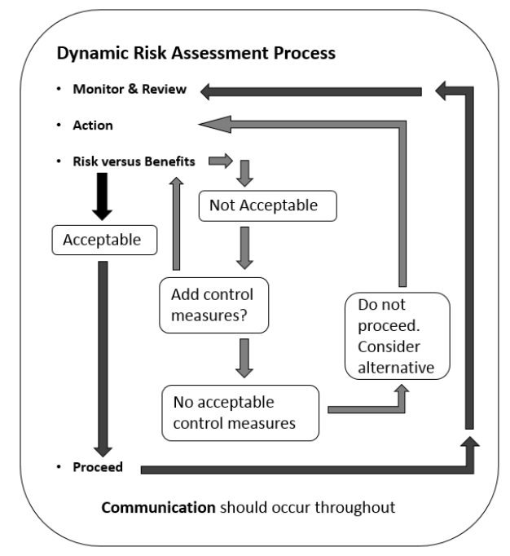
(Australian Adventure Activity Standards 2019)
Was significant dynamic risk assessment conducted during this activity last year resulting in change?
No – the progression of learning enhanced the safety of participants
Detail people involved, situation, action and communication
Novices – pre departure communication and info books provided.
What needs to result in the next similar instance?
No changes required

Emergency Management Planning Details

Planning
- emergency response actions, allocated roles and responsibilities
  - roles outlined in information pack and respones outlined below in incident and emergency plans
- closest available professional medical care (e.g. hospital, clinic, doctor)
  - outlined in information pack
- contingency plans for foreseeable emergencies (e.g. injuries, fire, flood)
  - walk west to Brookman Road, text leaders and wait for pick up
  - multiple access points indicated in maps and route if evacuation needed
  - dealing with injuries outlined below in incident and emergency response plans
- strategies relevant to the features of the area being visited
  - outlined in risk identification

Preparation
- emergency access and escape routes (where possible)
  - see route outlined in info pack
- assembly points where appropriate
  - brookman road between HQ and Kyeema
- details of key organisations (e.g. ambulance, land manager, local police) and how to best contact them in an emergency
  - outlined in information pack
- communication equipment that will be used, including coverage notes and/or limitations (e.g. mobile phone, satellite phone, radio)
  - outlined in leaders information pack
    - mobiles sufficient for locations
- relevant aspects of the land manager’s emergency strategy (e.g. gaining assess past locked gates)
  - outlined in information pack
  - no permits required for educational groups

Response
- the process or procedures for responding to an emergency
  - outlined below in incident and emergency response plans
- the process or procedures to confirm or ensure the safety of a group that fails to return or check-in as planned
  - outlined in flinsafe approvals
- the emergency trigger for a non-participating contact, to commence the planned process or procedures to confirm the safety of the group and/or inform emergency services if the group fails to return or check-in
  - outlined in flinsafe approvals
  - leaders to identify Joss of completion by 4.30pm
  - if no contact by 4.30pm, Joss to contact leaders
  - if no contact by 5pm emergency services will be notified
  - Joss notified as soon as possible of incident or emergency
- a strategy for maintaining appropriate participant supervision if the planned activity changes (e.g. an injured leader is evacuated or escorting participants who are withdrawing from the activity)
  - consult info pack and exit strategies
  - ratios must be maintained
  - follow check in procedures
  - phone procedures outlines emergency response
- access to personal contact and medical information
  - to be carried in hard copy by leaders
  - stored in flinsafe

Recovery
- reporting requirements for fatalities, serious injuries or illness and dangerous incidents
  - outlined below in incident and emergency response plans

Incident and Emergency Response Plans
Incident
- Apply first aid if necessary and manage the group
- Keep record via incident report form below
- Contact university contact as soon as practical
- If exit is needed then exit according to info pack for location and contact student emergency contact to collect
- If no exit is needed reassess and continue if able to do so with group
- If collected reassess and continue if able to do so with remaining group
- If no option for collection, alter trip to exit to nearest vehicle
- Once practical incident report must be entered to Flinsafe and national UPLOADS project
- Review to be conducted with group and reassess risk assessment and management

Emergency
- Have students call emergency services from mobile 000 or 112 (follow incident report form included)
- Manage group (instructor 1 to identify safe location and allocate leader to monitor).
- apply first aid (leader in charge to administer or delegate to willing trained first aider)
- Debrief group to what is happening. Group members positioned to help identify casualty site for emergency services.
- Prepare group and victim for evacuation via either air lift or identified exit location on the route outline
- Preserve site if major emergency or fatality where practical
- Evacuate group.
- Contact university contact and emergency contact as soon as practical
- Once practical incident report must be entered to Flinsafe and national UPLOADS project

- The effective management of any incident in the field will, for the most part rely on sound judgement and decision making from the group leaders on the scene.
- University to be consulted regarding student and staff support and counselling that is available.

Accident Report Form

Date of Accident_____________ Time of Accident ________________
Student Involved ____________________________
Location of Accident ___________________________________
Nature of Injury
_________________________________________________________________________
_________________________________________________________________________
_________________________________________________________________________
_____________ ____________________________________________________________

Description of Accident
________________________________________________________________________
_________________________________________________________________________
_________________________________________________________________________
_________________________________________________________________________
_________________________________________________________________________

Action taken by staff member
_________________________________________________________________________
_________________________________________________________________________
_________________________________________________________________________
_________________________________________________________________________

Name of witness or others present
_________________________________________________________________________
_________________________________________________________________________

Medical Referral ____________________________________________________________

Signature ________________________ Date _________________

Leader in Charge signature _______________________

Emergency – Serious Incident Form
(YOU MUST FILL IN THIS FORM FOR AN ACCIDENT THAT HAS CAUSED INJURY OR WHERE CONDITIONS REQUIRE MEDICATION OR ONGOING TREATMENT)

Name (patient)……………………………………………………………..…………… Date………………………………
Summary - Emergency Services Contact Information
We require an ambulance. My name is………………………………… We are a University group. Our location is…................................................................................................................................. (grid reference and description)
We have a casualty who is a ……………………..year old male/female whose Chief Compliant is:
……………………………………………………………………………………………………………………………………………………………………..
……………………………………………………………………………………………………………………………………………………………………..
……………………………………………………………………………………………………………………………………………………………………..
……………………………………………………………………………………………………………………………………………………......(symptom)
The patient states/witnesses state: (Mechanism of injury/History of present illness)
……………………………………………………………………………………………………………………………………………………………………..
……………………………………………………………………………………………………………………………………………………………………..
……………………………………………………………………………………………………………………………………………………………………..……………………………………………………………………………………………………………………………………………………………………..
Observations patient found (describe position). Patient exam reveals (observation / injury). Vital Signs at (time).
Patient Exam
……………………………………………………………………………………………………………………………………………………………………..
……………………………………………………………………………………………………………………………………………………………………..……………………………………………………………………………………………………………………………………………………………………..
Vital Signs
 | NORMAL | 1 | 2 | 3 | 4 | 5 | 6
TIME
General details
HR | 50-100bpm
RR | 12-20 (breaths/min)
SCTM | PINK/WARM/DRY
TEMP | 37 deg

HISTORY
Symptoms…………………………………………………………………………………………………………………………………………………………………….
Allergies……………………………………………………………………………………………………………………………………………………………………….
Medications………………………………………………………………………………………………………..……………………………………………………….
Pertinent medical history…………………………………………………………………………………………………………………………………………….
Last intake/output………………………………………………………………………………………………………………………………………………………
Events…………………………………………………………………………………………………………………………………………………………………………

ASSESSMENT (Problem list)………………………………………………………………………………………………………………………………………….
……………………………………………………………………………………………………………………………………………………………………..
………………………………………………………………………………………………………………………………………………………………………………………..…………………………………………………………………………………………………………………………………………………..

PLAN (Plan for each problem on assessment sheet)……………………………………………………………………………………………………..
………………………………………………………………………………………………………………………………………………………………………
………………………………………………………………………………………………………………………………………………………………………
……………………………………………………………………………………………………………………………………………………………………..

ANTICIPATED PROBLEMS…………………………………………………………………………………………………………………………………………….
……………………………………………………………………………………………………………………………………………………………………..
……………………………………………………………………………………………………………………………………………………………………..
……………………………………………………………………………………………………………………………………………………………………..

*also complete incident report above to describe incident
*take and attach photos as soon as safe and possible
Notes

COVID-19 Procedures for Outdoor Activities

The precautions below relate specially for students and adult staff in conducting activities as a part of outdoor activity programs including overnight expeditions. The below checklist has been developed with reference to the following documents which should be accessed for further clarity or information.
- COVID-19 Guidance Document for Camps, (Australian Camps Association Version 1, 5 May 2020) https://auscamps.asn.au/about/latest-news/covid-19-guidance-document-camps
- Outdoor Council Of Australia (OCA) Framework for Rebooting Outdoor Activities in a COVID-19 Environment Final Copy 7 May https://www.outdoorcouncil.asn.au/wp-content/uploads/2020/05/OCA-Framework-for-Rebooting-Outdoor-Activities-in-a-COVID-19-Environment-Final.pdf
- THE AUSTRALIAN INSTITUTE OF SPORT (AIS) FRAMEWORK FOR REBOOTING SPORT IN A COVID-19 ENVIRONMENT https://ais.gov.au/__data/assets/pdf_file/0006/730374/35845_AIS-Framework-for-Rebooting-Sport-Summary.pdf

In preparing this document we reiterate the disclaimers provided as well as recognise the evolving information provided by both state and federal governments and specifically the SA roadmap to recovery from COVID-19 https://www.covid-19.sa.gov.au/recovery?gclid=CjwKCAjwte71BRBCEiwAU_V9h4H4sev25WsUGosU_UCHbIpXVXN_ZY0zm6uZFM-r8TYh0Ocn2-DLTBoCYfAQAvD_BwE

In general, at this time the risk of transmission is believed to be very low with no community transmission. As time passes it is expected that this document will need to adjust to reflect best practice and government directive.

Please note that we do not claim to be experts in the management of COVID-19 and have prepared a list of suggested actions when considering returning to Outdoor Learning as part of a school’s education programs in SA only. We take no responsibility for the actions carried out by others and stress that SA Health and Federal Government advice must be followed at all times. You must also continue to carry out your own risk management and assessment as per usual and consider your own context in considering the following.

OE COVID-19 Risk Management – Check List
At the beginning of the trip, all participants and staff will be asked to self-declare in regards to the following. Attending the trip means you are abiding by the following.

For Students (monitored, modelled and communicated by staff)
- Not to attend if showing symptoms of COVID-19 eg. fever, dry cough, tiredness prior to trip
- Not to attend if been in contact with a confirmed case of COVID-19 in previous 14 days
- Not to attend if been in contact with someone in quarantine or self isolation in previous 14 days
- Not to attend if you have been to a hot spot or been instructed to isolate by SA Health
- Hands need to be washed after using public facilities and have soap / alcohol-based hand wash in case public toilets do not
- Wash hands regularly, including before and after activity if using your hands and are touching equipment; eg climbing, kayaking, trowels
- Try and decrease the amount of times you touch your face
- Coughs / sneezes into your elbow
- Physical distancing will be applied where practical by remaining 1.5m from others.

For Staff
- Not to attend if showing symptoms of COVID-19 eg. fever, dry cough, tiredness prior to trip
- Not to attend if been in contact with a confirmed case of COVID-19 in previous 14 days
- Not to attend if been in contact with someone in quarantine or self isolation in previous 14 days
- Not to attend if you have been to a hot spot or been instructed to isolate by SA Health
- Hands need to be washed after using public facilities and have soap / alcohol-based hand wash in case public toilets do not
- Wash hands regularly, including before and after activity if using your hands and are touching equipment; eg climbing, kayaking, trowels
- Try and decrease the amount of times you touch your face
- Coughs / sneezes into your elbow
- Physical distancing rules of 1.5m must be applied for adults
- Staff and students to be monitored for COVID-19 symptoms eg. fever, dry cough, tiredness
- If symptoms develop for any staff or student self-isolate from group and get medically tested as soon as possible – call medical facility in advance
- Staff to carry additional disposable gloves
- Staff to carry soap / alcohol-based hand wash
- If presenting to hospital for testing, the teacher transporting and the individual with symptoms to wear face mask

For Parents (if student under age of 18)
- Must openly communicate about their child displaying symptoms prior to trip to staff or of any contact with a confirmed case of case awaiting results
- Parents to be aware that if their children presents with Covid-19 symptoms that they need to relieve OE staff at the nearest hospital or pick their child up

Transport
- Students to be transported in vans or buses to follow current transport regulations (currently no restrictions)
- Students to fill up the back of the bus first to reduce student contact
- Students to sit on the same seat each time they re enter the vehicle
- Breaks to be minimised to decrease use of public facilities but enough breaks to be driver safe
- Where possible drivers will stop at different locations to reduce numbers in one place

General Camping (not applicable for day trips)
- Tent per person whilst base camping
- Head to toe sleeping in expedition tents with no more than 2 in a tent
- Cooker shared but individual cooking, eating and eating equipment. Use sanitiser
- Dorm or hut use to be minimised or avoided
- Group facilities to be cleaned regularly
- Use as much space as available

Activity
- Equipment to be cleaned with disinfectant or soapy water after use (precautions must be given where integrity of equipment will be compromised such as climbing equipment)
- Where cleaning cannot be applied above advice for personal hygiene will be followed and equipment sharing to be avoided or alternative sought.
- For further activity specific advice at this stage please refer to https://www.outdoorcouncil.asn.au/wp-content/uploads/2020/05/OCA-Framework-for-Rebooting-Outdoor-Activities-in-a-COVID-19-Environment-Final.pdf

